Project Design Phase
Solution Architecture

Date | 26-06-2025
Team ID | LTVIP2025TMID19414
Project Name | BookNest
Maximum Marks | 4 Marks

Solution Architecture:
Solution architecture is a strategic and multifaceted process that connects business challenges with effective technological solutions. It involves several interrelated activities with the following key objectives:
- Identifying the most suitable technology to address current business needs.
- Communicating the system's design, structure, functionality, and behavior to stakeholders in a clear and comprehensive manner.
- Defining core features, development stages, and technical and business requirements of the solution.
- Establishing detailed guidelines and specifications for how the solution will be planned, developed, implemented, and maintained.

Example - Solution Architecture Diagram:

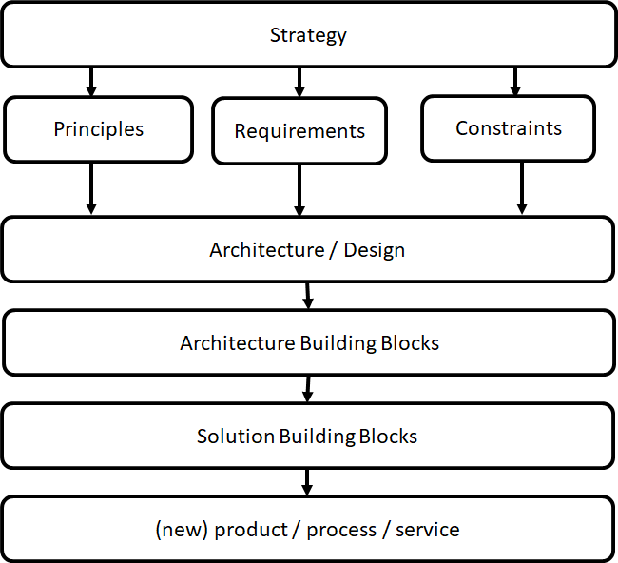
This Photo by Unknown Author is licensed under CC BY-SA
Figure 1: Architecture and data flow of the voice patient diary sample application
Reference: https://aws.amazon.com/blogs/industries/voice-applications-in-clinical-research-powered-by-ai-on-aws-part-1-architecture-and-design-considerations/

